Team,

Please see below. These 2 IDs have submitted these jobs for NTS review but have selected VBHS ownership. Please educate all your non-DSP not to select ownership. They should keep the current owner as it populates.
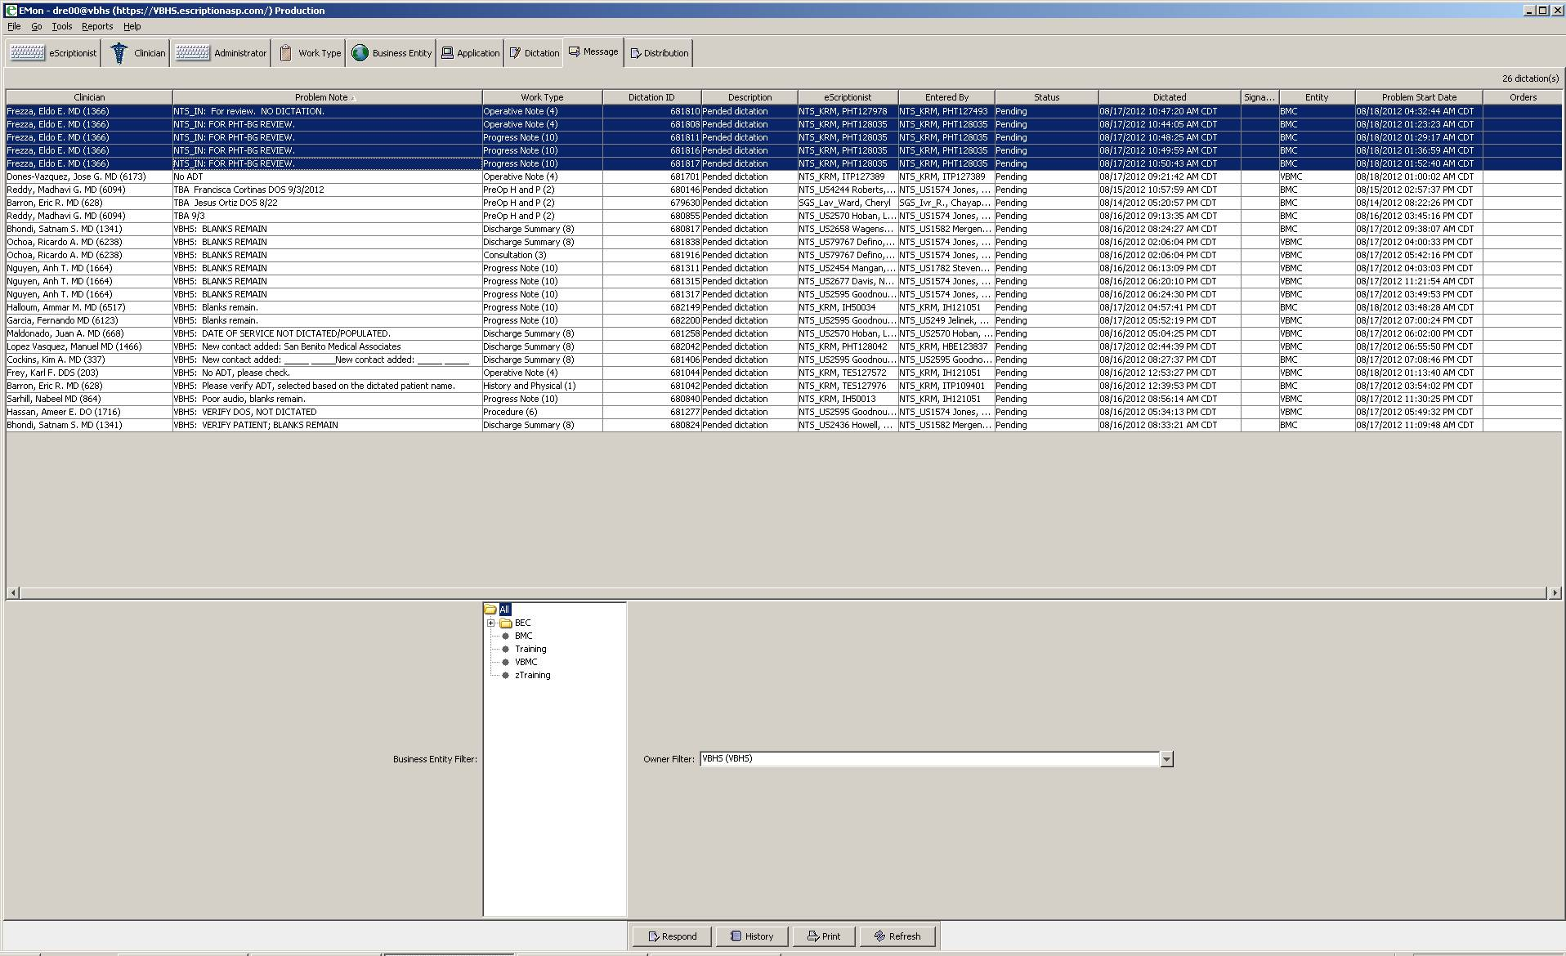N
This Message (including any attachments) is confidential and intended solely for the use of the individual or entity to whom it is addressed, and is protected by law. If you are not the intended recipient, please delete the message (including any attachments) and notify the originator that you received the message in error. Any disclosure, copying, or distribution of this message, or the talking of any action based on it, is strictly prohibited. Any views expressed in this message are those of the individual sender, except where the sender specifies and with authority, states them to be the views of Vanguard Health Systems.

