Team,

Please see below feedbacks from client. Please read my comments marked in red. I have requested the client to send us the list of authors who need signing clinician. I will share it with you as soon as I have it.

Look Below
George Pierce is a PAC. He does not have signing rights and always needs a signing clinician. For below job, he says “Dictating for Dr. Donald Roa,’ which means you need to select Dr. Donald Roa as a signing clinician.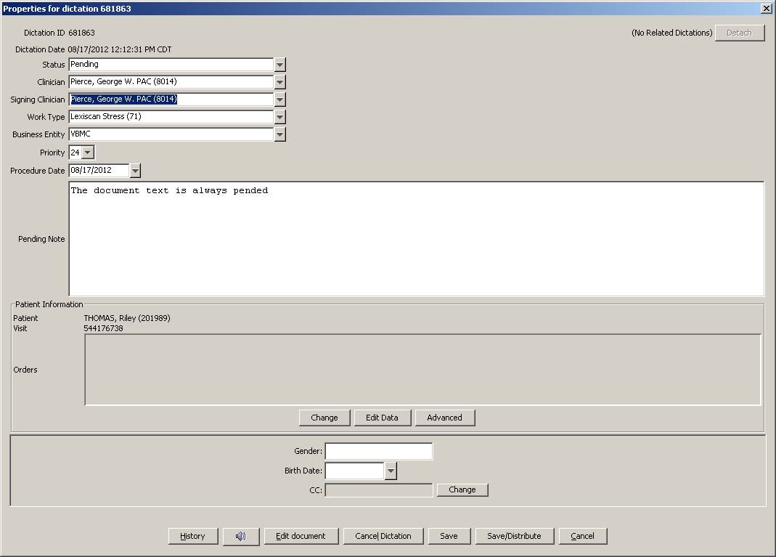

Job# 681864
Here, he says dictating for Dr. Mild. Job got autopended.
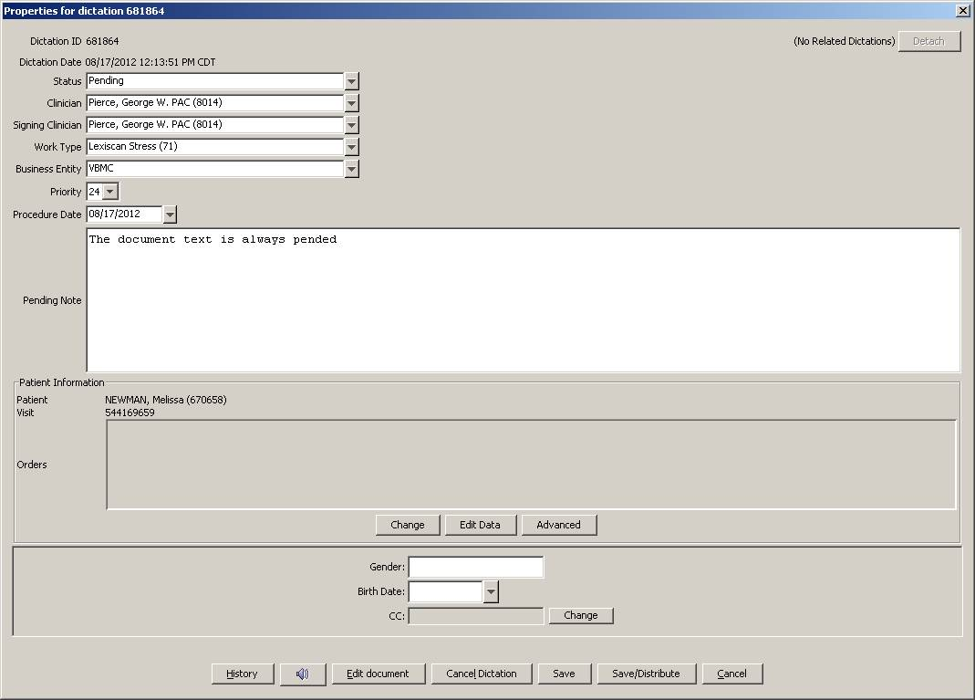

Job# 681865
Here again, he says dictating for Dr. Mild. Job got autopended
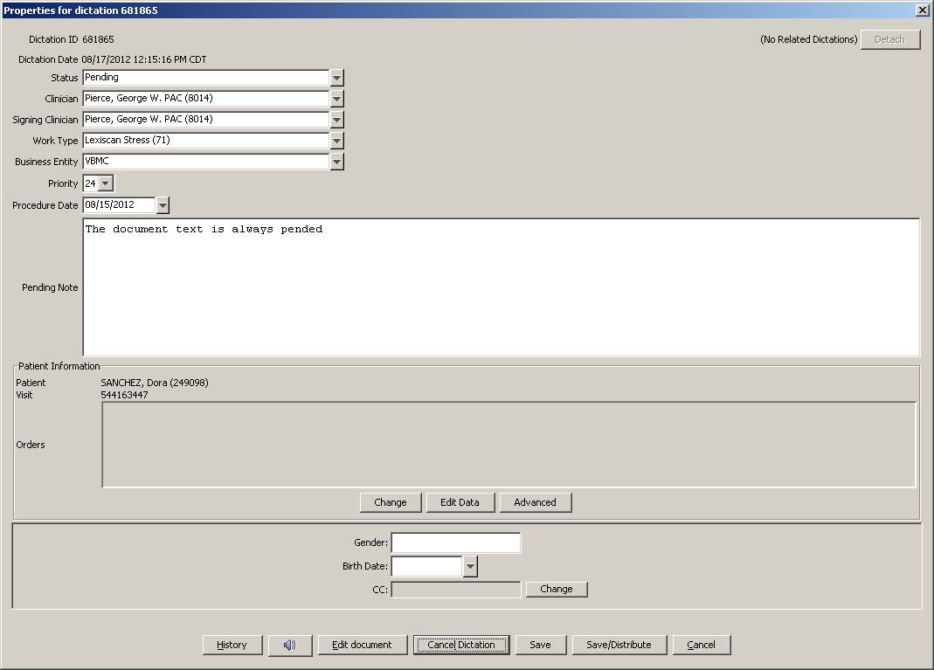

Should be Dr. Adames and not Dr. Thomas
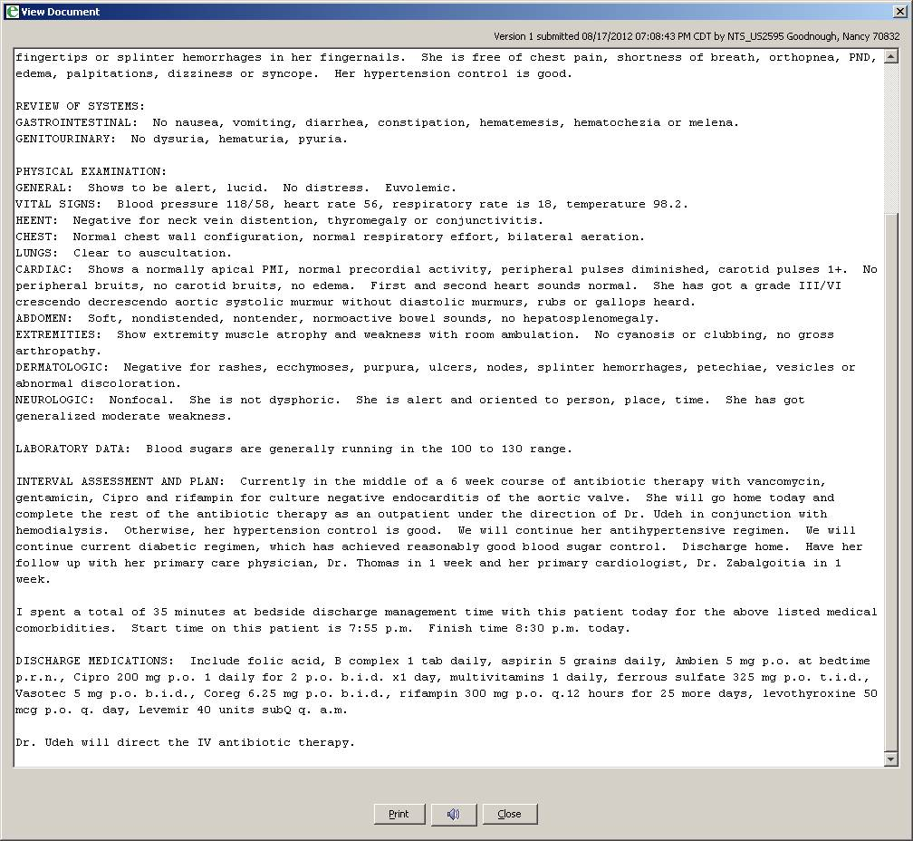

Job#681782
Never use patient name in the body of the report. This is very clearly mentioned in the account specifics. Please remove the patient’s name and use “The patient”
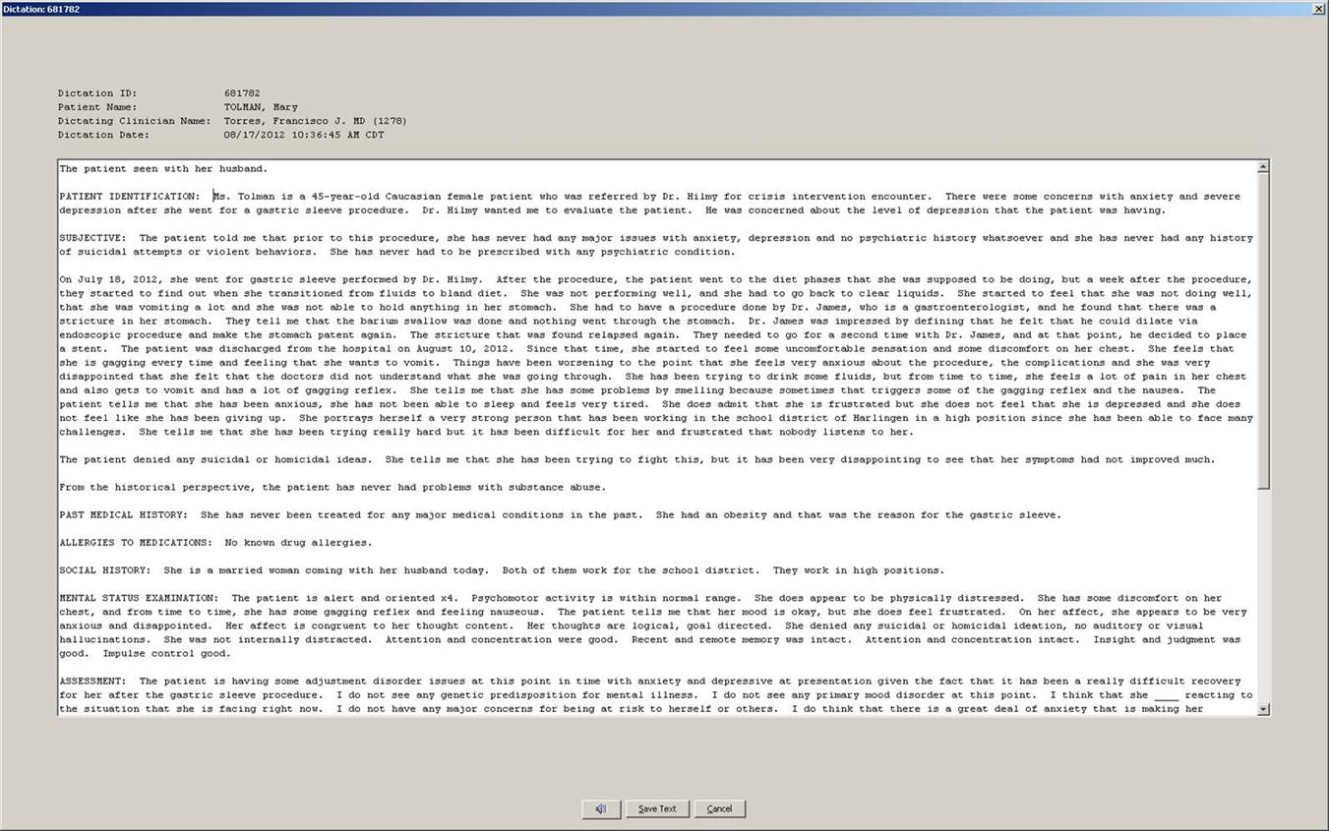

Job#682215
Dictates “my attending Dr. Broughton”
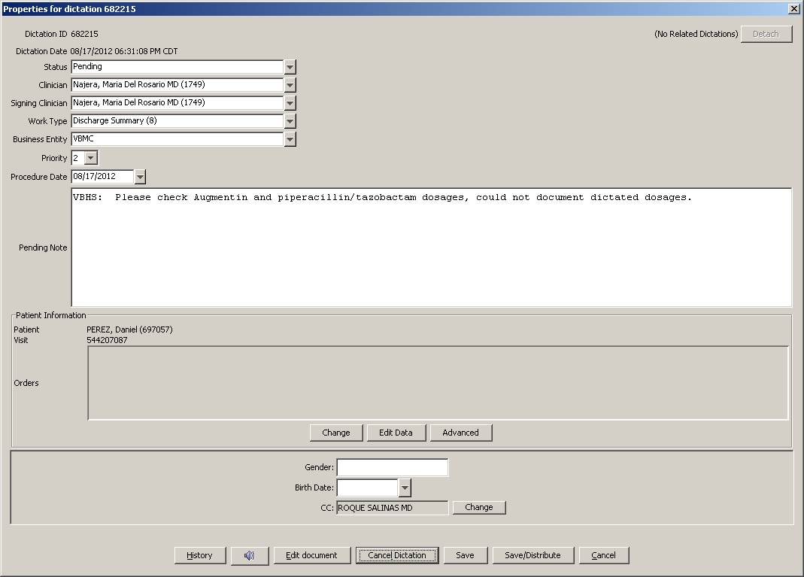

Job#682901
She says “Dictating for Dr. Vasquez (Pedro)”
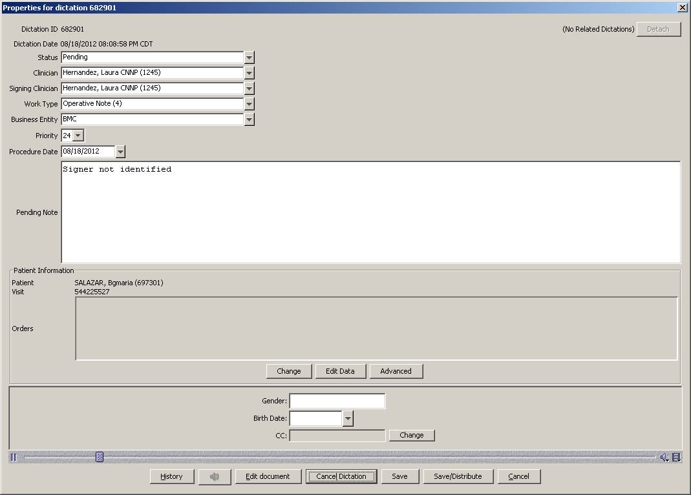
This Message (including any attachments) is confidential and intended solely for the use of the individual or entity to whom it is addressed, and is protected by law. If you are not the intended recipient, please delete the message (including any attachments) and notify the originator that you received the message in error. Any disclosure, copying, or distribution of this message, or the talking of any action based on it, is strictly prohibited. Any views expressed in this message are those of the individual sender, except where the sender specifies and with authority, states them to be the views of Vanguard Health Systems.

