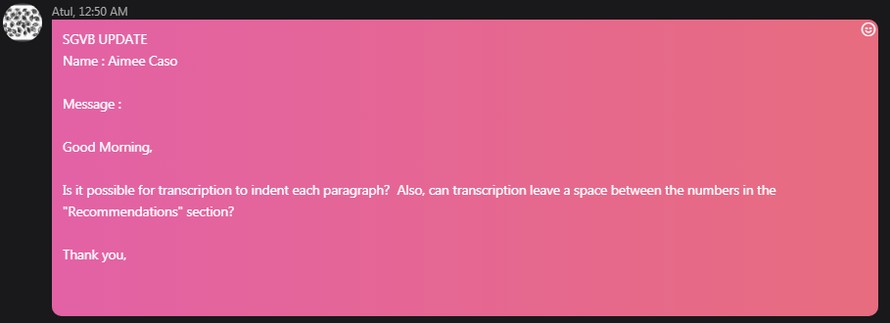

**INDENTION IN EACH PARAGRAPH**

You may also refer to the latest samples in S4Y portal.

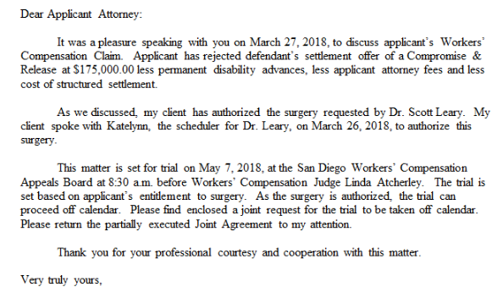

**LEAVING A SPACE IN BETWEEN NUMBERS IN THE “RECOMMENDATIONS” SECTION**

You may also refer to the latest samples in S4Y portal.

