Vanguard Baptist Security Groups

NTS_ 4 HR | Neonatal (11)
 | PreOp H and P (2)
 | Transfer Note (16)
NTS_ 6 HR | Echocardiogram (14)
 | Foot Care Institute (13)
NTS_ 8 HR Operative | Operative Note (4)
 | Procedure (6)
NTS_ 8 HR | Behavior Health H and P (20)
 | Behavior Health Progress Note (23)
 | Behavior Health Psych Evaluation (21)
 | Brwns Psych Eval (17)
 | Brwns Psych Progress Note (18)
 | History and Physical (1)
 | IBH Clinic Evaluation (24)
 | IBH Clinic Progress Note (26)
 | Progress Note (10)
 | Psychiatric Evaluation (27)
 | Psychiatric Progress Note (29)
NTS_ 8 HR Cardio | Excercise Stress (72)
 | Lexiscan Stress (71)
 | Rest Stress (70)
 | Resting MUGA Right Ventricular First Pass (73)
 | Resting Thallium with Delay (74)
NTS_12 HR | Consultation (3)
 | Delivery Note (7)
 | ED Assessment (5)
 | EEG (12)
 | Psychiatric Consult (19)
 | Wound Care Center (30)
NTS_24 HR | Behavior Health Psychiatric Discharge Summary (22)
 | Dialysis (31)
 | Discharge Summary (8)
 | IBH Clinic Discharge Summary (25)
 | Psychiatric Discharge Summary (28)

TAT Hours: Below is the TAT breakup.
Go-Live | TAT AND LINE DISTRIBUTION
 | <2 | 2 to 4 | 4 to 6 | 6 to 8 | 8 to 12 | 12 to 24 | >24 | Total
15-Aug | 0 | 83 | 0 | 14649 | 4701 | 4093 | 0 | 23526
Total | 0 | 83 | 0 | 14649 | 4701 | 4093 | 0 | 23526

1. Please note that for Neonatology Reports their problem lists do NOT follow a chronologic sequence order so when the speaker identifies the problem, it may start with PROBLEM #1 followed by PROBLEM #5, followed by PROBLEM #2, etc. Leave as dictated. Do not change the order.

2. Please see below feedbacks from client. Please read my comments marked in red. I have requested the client to send us the list of authors who need signing clinician. I will share it with you as soon as I have it.

Job# 681863
George Pierce is a PAC. He does not have signing rights and always needs a signing clinician. For below job, he says “Dictating for Dr. Donald Roa,’ which means you need to select Dr. Donald Roa as a signing clinician.
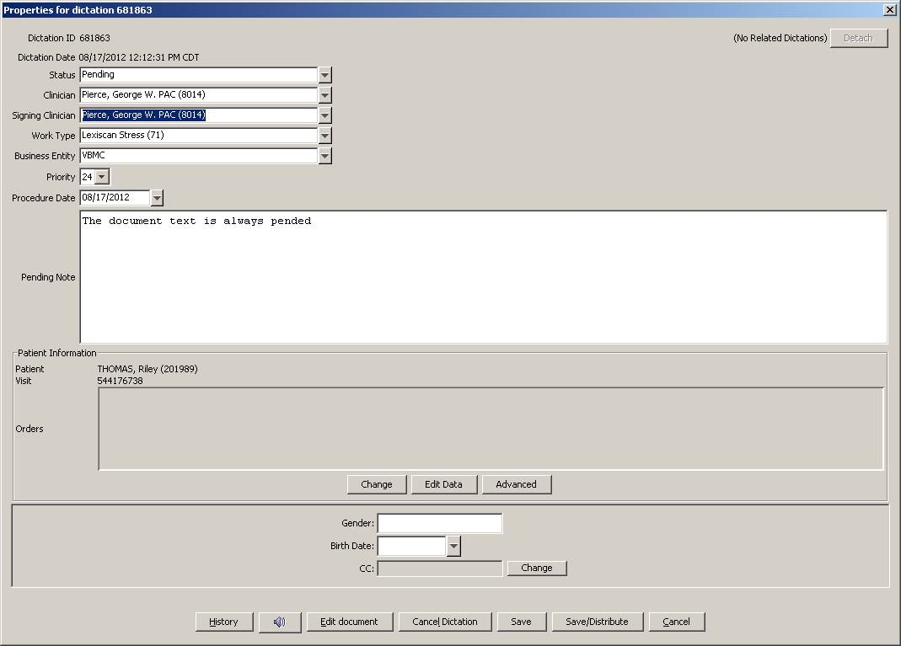

Job#681782
Never use patient name in the body of the report. This is very clearly mentioned in the account specifics. Please remove the patient’s name and use “The patient”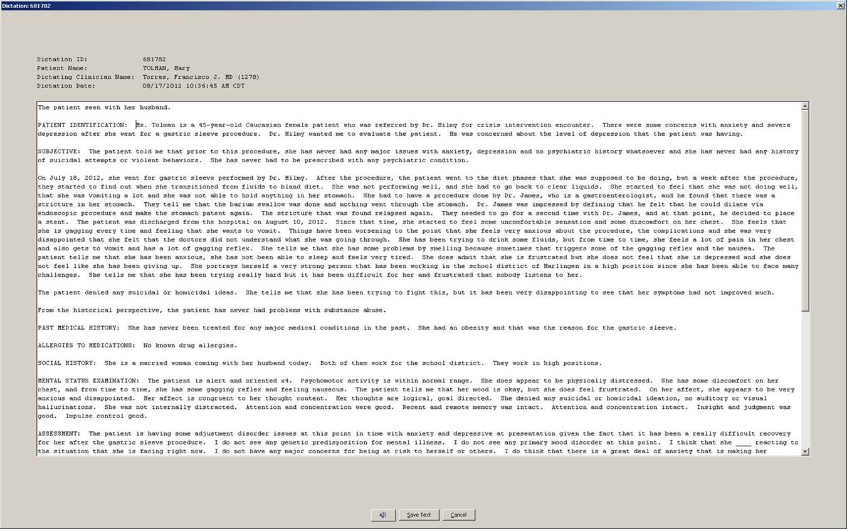

3. Dr. Shenkenberg needs all his reports as a priority within TAT. He gets upset if his jobs are delayed or out of TAT.

4. An update. When Dr. Lopez dictates his progress notes, he dictates: “CARDIOVASCULAR, bold and underline”. He dictates this on all of the physical exam headers. We know it is not possible to bold and underline in this system. Just leave the header as is. Client wants us to know what exactly is being dictated, because we had few reports where MTs transcribed it as CARDIOVASCULAR: Underlying. Sinus rhythm.

5. Date of Birth not prefilled in the header: We have seen multiple reports with DOB field not prefilled. Please go ahead and fill it as per the ADT.

6. Split Dictations: We have requested the authors to clearly dictate the MR# and the patient name while dictating multiple patients. If you still face the problem with ADT selection, please select unknown patient and pend it for client review.

7. Signed Samples: We had requested the client to send us signed samples of Dr. Gerardo Sanchez and Dr. Ricardo Ochoa. Client wants us to use the samples available in the database. Both of these authors have signed their rat eports and have not made any changes/corrections.

8. Hernandez, Laura CNNP (1245): Laura Hernandez dictates for “Dr. Sanchez,” but only Gerardo Sanchez is the Neonatologist for BMC and should be selected as the signing clinician. Do not select Dr. Erwin Sanchez. He is from VBMC business entity. We are putting an MT instruction in place.

9. Date of Assessment, Date of Admission and Date of Discharge: Few authors dictates these dates. Please DO NOT add them in the body of the report. Strictly follow MT instructions for Date of Service.

10. Worktype Change: Flores, Jorge H. MD (6237) keys in wrong worktype. He keys in Progress Note but dictates H&P. Please be extra careful with his reports and change the worktype as dictated. Example job#.684972, 684970, 685701.

11. Job# 685628 – MT left in “I want you to erase Subjective” – those were just instructions to the MT, and MT transcribed it.

12. Job# 685488 – This report had a contract in it – first sentence contained “that’s” DO NOT use contractions.

13. Sanchez, Gerardo D. MD (24329): Please check MT instructions.
  - Under Progress Notes, authors requests to insert normal Physical Exam template for Male/Female twice. Please insert it only once.
  - Vital Signs if not dictated, please delete it.
  - At the end of the report he dictates, “dictation to be checked for accuracy.” Please retain the text at the bottom of the report as dictated.

14. Co-signer for PACs/RNs: PACs and RNs require signing clinician. They always will dictate the co-signer’s name. Please put the name in the signing clinician field. Please check MT instruction.
15. – Please do NOT touch any pending report that shows //TBA at the front of the pending note. These have already been touched by the client and they are awaiting demographics.

16. Todd D. Shenkenberg, MD (320) - I am seeing lot of his dictations being pended with the pend note “Please Verify ADT.”

Please note that he dictates 11 digit numbers in the ADT details, i.e., 0 – 0 - then 6 digit numbers and then 3 digit numbers (e.g. 00523661-442). While selecting the ADT, please ignore first two zeros and the last 3 digits (this is the room number). Put only the 6 digits in the MRN field and search, you will get the ADT. If you still do not get it, please pend the job.

17. Please note that Sarhill, Nabeel MD (864) wants ROS and PE templates to be inserted in all of his H&Ps, PNs, and Consults. Note that he always dictates only the abnormal findings. He wants us to insert these templates and make necessary corrections as dictated.

I reviewed few of his reports and found that he sometimes requests to insert the PE template but never requests for ROS one. We are putting an MT instruction in place and I will let you know once it is updated.

For now, please follow this for all his H&Ps, PNs, and consults. Insert ROS and PE template by default.

18. For NO DICTATIONS, the monitoring teams should be changing the Work Type to No Dictation/Hang Up (999) and the Status to Transcribed. MTs/QCs will pend their jobs to NTS with appropriate comments.

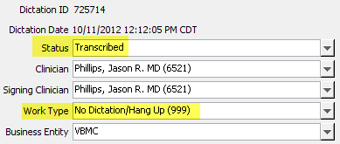

19. Dr. Madhavi Reddy: Again, we are hearing from Dr. Madhavi Reddy. She requests a template to be inserted, but please be careful with the Anesthesia part. Though the anesthesia autopopulates in the template, we need to type it as she dictates it. Also, she states that when she is dictating a normal phaco with implantation, MTs are selecting the complex phaco template. Please be extra careful while selecting her normals. We have added the standard phaco template. it is named as BMC_Reddy_Normal Phaco.

20. Incorrect Worktype: We are seeing multiple reports with incorrect worktypes. We know few authors are keying in wrong worktype, but we will have to change the worktype as dictated. If not sure, pend it for internal review to verify worktype.

21. Dr. George Pierce: This is my third reminder mail on this author, but we are still seeing jobs without co-signer. Please insert the signing clinician as dictated. We have now put an MTI in place. Please go through it. Once again, Dr. George Pierce always need a signing clinician, and he always dictates one.

22. Dr. Ameer Hassan. We have created a template for the intervention. It is named as VBMC_Hassan_Intervention. Please make a note of it. Also, we have added few more templates for him. Please be careful with the templates that he requests.

Please be very very careful with Dr. Hassan’s dictations. He never requests to insert the template. You need to get a hint from the way it is being dictated. The word “template” should give you a hint. Please see below report dictated, and I have marked the portions yellow where we were supposed to insert the template and our MT missed it. All these normals are available in our database. Please see below. Moving forward, please ensure that all his reports are double checked for templates and all normals/templates are inserted appropriately. We cannot afford to have regular client feedback on such critical issues.
History of Present Illness: A boy with intracerebral hemorrhage in the left parietooccipital area. The patient is here for diagnostic cerebral angiogram to rule out arteriovenous malformations, arteriovenous fistula and/or aneurysm.

Fluoroscopy time: 6.1 minutes.
Contrast used: 84 cc.
Versed 0.5 mg.
Fentanyl 25 mcg.
Time in: 4:30 p.m.
Time out: 4:58 p.m.

Normal right common femoral artery template.

Normal left vertebral artery template.

PCOM is filling. There are abnormal branches of the left and right PCA but no evidence of early venous filling.

Normal right internal carotid artery template. ACOM is visualized. PCOM is visualized.

Normal right external carotid artery template.

Normal right vertebral artery template. Again noted are abnormal branches off of the left and right PCA (P2 segments with no obvious early venous filling).

Normal left internal carotid artery template. ACOM is visualized. PCOM is not visualized.

Normal left external carotid artery template.

IMPRESSION: There is no obvious early venous filling or evidence of arteriovenous malformation, arteriovenous fistula or aneurysm.

PLAN: Repeat diagnostic cerebral angiogram in three months and we will follow up in clinic after angiogram is completed.

23. Dr. M. Reddy/Dr. Baron/Dr. Hyde: We have an updated MTI in place for these physicians. Please see below an updated MTI.
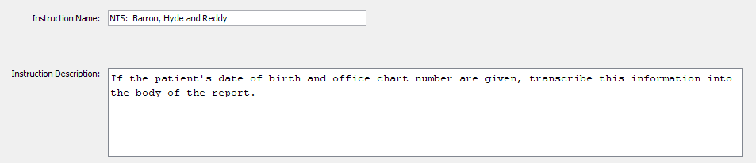

24. Incorrect worktypes: Another issue on which we are now receiving regular feedbacks are the Incorrect Worktype. Please see mail below from the client and also attached mail.

Most of these reports authors are keying in incorrect worktype, and we have to correct it as dictated. Please always double check the worktype populated in the header field versus what report type is being dictated.

25. Update on Movva Prasad:
We know, Dr. Movva dictates a mysterious “cc” at the end of the report, and we are either leaving it as a blank or pending the job to client for CC verification. Please note that, IT IS HIM. He requests a copy to himself and wants it to be faxed to him. You just need to add his name just like a regular cc. He is already set up with his fax.
PLEASE DO NOT PEND HIS FILES FOR CC VERIFICATION.
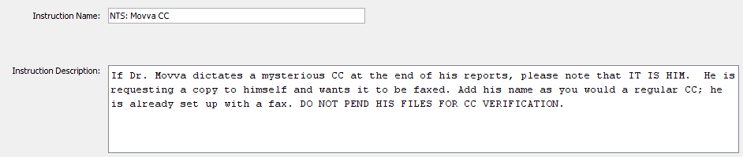

26. Continuation Dictations:
Recently it has been brought to our attention, by the client, that many of the dictators are dictating “this is a continuation” or “this is a continuation of a dictation.” It is the client’s request that we transcribe what is dictated by the dictator rather than putting Addendum as the first line of text. A continuation would then be pended to the client so that they may combine the previous report with the continuation. The report would look something like the following:
This is a continuation.
The patient was then placed in the lithotomy position and general anesthesia administered……..

We will now only transcribe Addendum if the dictator specifies “this is an addendum.” Otherwise, if the dictator does not say “this is an addendum” specifically and does not say “this is a continuation,” the report is not a complete report, and begins somewhere other than at the beginning of a normal dictation, we will treat it as a continuation and pend to the client as follows: VBHS: Continuation.

27. Please make a note of Dr. Cheng-hurd Liu’s (6186) typical style of dictating the Progress Notes. He dictates the problem number list in random order and we have to go strictly as dictated. Please DO NOT correct the order. See below example. He wants it the way he has dictated it. Also, very important to note that almost all his reports come in as unknown worktype, but he dictates Progress Notes, and if any other report type, he will specify it in the beginning of the report. Please change the worktype as dictated.

See the Example below:_____________________________________________________________________________________

DATE OF BIRTH: 11/7/2012.

HOSPITAL DAY #2.

PROBLEM #1 Thirty-seven weeks, birth weight 2495 g. Baby remains on frequent vital sign monitoring, Level 2 care.

PROBLEM #2 Nutrition: Today's weight 2277 g, degrees 218 g since birth, currently the baby is on TPN as well as feeding, total intake 110 mL per kg/day. Feeding EBM or Simulac Sensitive, 14 mL q.3 hours, increase 1 mL q. feed. Total feeding, voiding and stooling this morning. This morning's lab glucose 89, BUN 12, creatinine 0.5, sodium 142, potassium 5.6, chloride 105, calcium 9, phosphorus 7, magnesium 1.9. The baby's abdomen remained soft.

PLAN:
1. Continue TPN as well as the feeding, increase total intake to 140 mL per kg/day.
2. Adjust components of TPN based on today's lab. Repeat Panel-2 in a.m. as per protocol.
3. Increase feeding by 3 mL q. feed and observe.

PROBLEM #4 Suspected sepsis: Mom's GBS was negative. The baby is on room air at this time. The baby is on gentamicin on day #2 out of possibly 3. Blood culture remains negative.

PLAN:
1. Continue Ampicillin and gentamicin day #2 out of 3.
2. Follow blood culture results.

PROBLEM #4 Hypotension: Blood pressure mean 50's, urine output adequate, good perfusion. Close observation at this time.

PROBLEM #6 Occasional bradycardia and history of dusky spell: There was an EKG and cardiology evaluation on November 8, indicating patent foramen ovale/tricuspid insufficiency/normal EKG. There was no further dusky spell.

The baby had a cranial ultrasound on November 8, showed no IVH.

PLAN:
1. Close observation at this time.

MEDICATIONS:
1. Ampicillin.
2. Gentamicin.

PHYSICAL EXAMINATION:
VITAL SIGNS: Heart rate 120, respiratory rate 40, O2 saturation high 90s, blood pressure mean 50s.
HEENT: Fontanel is soft.
CHEST: Breath sounds are equal, good air exchange.
HEART: Regular rhythm, there is no heart murmur heard.
ABDOMEN: Soft, no distention, bowel sounds are present.
EXTREMITIES: Fair pulses.
SKIN: Color pink. Good perfusion. _____.

ADDENDUM: I spoke with the baby's mom and family through interpreter regarding the baby's overall condition and treatment plan.

28. An MTI for WT verification has been created that reads as follows:

NTS: Verify Worktype
**IMPORTANT*** Please verify the correct work type has been selected and matches the dictated report prior to submission. If it is unclear, pend to the client for verification of the work type as follows: VBHS: Verify work type

I anticipate a reduction in these work type errors going forward. J

29. Dr. Shenkenberg dictates mostly PNs, and for him HP or Consult will not begin with SUBJECTIVE, which should give us a hint that it is not HP or Consult but a Progress Note. If any doubts, you can pend it for VBHS review.

30 Dr. Sarhill only wants the ROS on his consultations and H&Ps, not the progress notes. If he does not dictate anything about the ROS then please leave it off.

31. NEW PHYSICIAN IN DATABASE - Miguel A. Di Francisco, MD- His ID is 1808. He is Internal Medicine.

32. Dr. Kotta - If a room # is given and no other patient details, we can pend to VBHS for verification and include that room # for the facility.

33. Ruben Lopez - has two different IDs. When selecting him as the signer, make SURE NOT TO choose the entry whose ID begins with 00.

34. Dr. Jover versus Dr. Hoover. Sound alike physician names. Please be extra careful. Dr. Jover is a Brownsville MD and Dr. Hoover is Harlingen. It is easy to confuse these two.

35. Dr. Sarhill - MTs are inserting the ROS in Progress Notes too. Please be careful of this.
  - Per instruction - Dr. Sarhill only wants the ROS on his consultations and H&Ps, not the progress notes. If he does not dictate anything about the ROS then please leave it off.

36. Dr. Pelly called up asking that when he dictates the date in the beginning of the report to please add it to his progress notes at the top. He is not a regular physician though. Please make a note of it.

37. Dr. Arredondo’s Auditor Evoked Potential template has been updated in the database. Please make a note of it and use it as dictated.

38. Dr. Chikkala There was an H&P pended to VBHS for co-signer verification. He says “Dr. Vasquez” and the MT pended as there are two Dr. Vasquez. Note that Dr. Chikkala actually usually dictates for Dr. Claudia Aguero-Vazquez.

39. New Locum Tenens Physician Effective 01/10/2013: Kamaldeen R. Saldin, MD - VBMC ID#1653 - Neurology. This author has already started dictated.

40. Incorrect WT - Mark M. Hayden, MD (0637) always key-in WT as progress note and dictates Emergency Department Note i.e., ED Assessment. It has been observed that some MLS’ do not change the WT and keep the same as PN. Please be very very careful.

41. Dr. Kim Cockins and Dr. Satnam Bhondi always key in MRN in the Account Number field. Always try and search for the ADT using that number in the MRN field. Also, you can use other information like patient name to search the ADT. With this you can avoid unnecessary pendings.

42. Gaitan, Luis E. MD (708) – Dr. Gaitan does not require a co-signer anymore. He gives the attending. Put it in the body of the report. DO NOT add the attending as co-signer.

43. Dr. Ruben Lopez - If the resident dictates “dictating on behalf of Dr. Ruben Lopez” that means Dr. Lopez is the co-signer.

44. Zaidi, Sajjad MD (1632) – Note that an MT instruction is in place for Dr. Zaidi that reads, NTS: Zaidi Dates - Please transcribe the date of service, date of admission, and date of discharge in Dr. Zaidi's reports if he dictates them.

45. Kuye, Taiwo A. MD (1282) - Dr. Kuye is no longer a resident and doesn’t need a co-signature. Please make a note of it.

46. Charles Allen Hare, PA-C (1865) – A new dictator added to the system. He will be working with emergency room physicians

47. Jose Espinoza, FNP – A new dictator to the system. His ID# is 1830. He will be working with ER physicians.

48. Client pended jobs – All QCs, please do not pick Jobs with the pend note starting with //TBA. These are jobs pended by the client for further clarifications.

49. DON W. HILL, MD - VBMC ID#1861 - ---Hematology /Oncology - A new physician has been added to the system. He does not need a second signature. He is also with Dr. Todd Shenkenberg, so we need to treat his dictations the same as Dr. Shenkenberg’s.

50. Pending with Unspecified reason – Client is seeing multiple reports being pended with Unspecified Reason. Any job pended to client should have appropriate pend note. DO NOT leave pend note box empty.

