Vanguard Baptist Security Groups

NTS_ 4 HR | Neonatal (11)
 | PreOp H and P (2)
 | Transfer Note (16)
NTS_ 6 HR | Echocardiogram (14)
 | Foot Care Institute (13)
NTS_ 8 HR Operative | Operative Note (4)
 | Procedure (6)
NTS_ 8 HR | Behavior Health H and P (20)
 | Behavior Health Progress Note (23)
 | Behavior Health Psych Evaluation (21)
 | Brwns Psych Eval (17)
 | Brwns Psych Progress Note (18)
 | History and Physical (1)
 | IBH Clinic Evaluation (24)
 | IBH Clinic Progress Note (26)
 | Progress Note (10)
 | Psychiatric Evaluation (27)
 | Psychiatric Progress Note (29)
NTS_ 8 HR Cardio | Excercise Stress (72)
 | Lexiscan Stress (71)
 | Rest Stress (70)
 | Resting MUGA Right Ventricular First Pass (73)
 | Resting Thallium with Delay (74)
NTS_12 HR | Consultation (3)
 | Delivery Note (7)
 | ED Assessment (5)
 | EEG (12)
 | Psychiatric Consult (19)
 | Wound Care Center (30)
NTS_24 HR | Behavior Health Psychiatric Discharge Summary (22)
 | Dialysis (31)
 | Discharge Summary (8)
 | IBH Clinic Discharge Summary (25)
 | Psychiatric Discharge Summary (28)

TAT Hours: Below is the TAT breakup.
Go-Live | TAT AND LINE DISTRIBUTION
 | <2 | 2 to 4 | 4 to 6 | 6 to 8 | 8 to 12 | 12 to 24 | >24 | Total
15-Aug | 0 | 83 | 0 | 14649 | 4701 | 4093 | 0 | 23526
Total | 0 | 83 | 0 | 14649 | 4701 | 4093 | 0 | 23526

1. Please note that for Neonatology Reports their problem lists do NOT follow a chronologic sequence order so when the speaker identifies the problem, it may start with PROBLEM #1 followed by PROBLEM #5, followed by PROBLEM #2, etc. Leave as dictated. Do not change the order.

2. Please see below feedbacks from client. Please read my comments marked in red. I have requested the client to send us the list of authors who need signing clinician. I will share it with you as soon as I have it.

Job# 681863
George Pierce is a PAC. He does not have signing rights and always needs a signing clinician. For below job, he says “Dictating for Dr. Donald Roa,’ which means you need to select Dr. Donald Roa as a signing clinician.
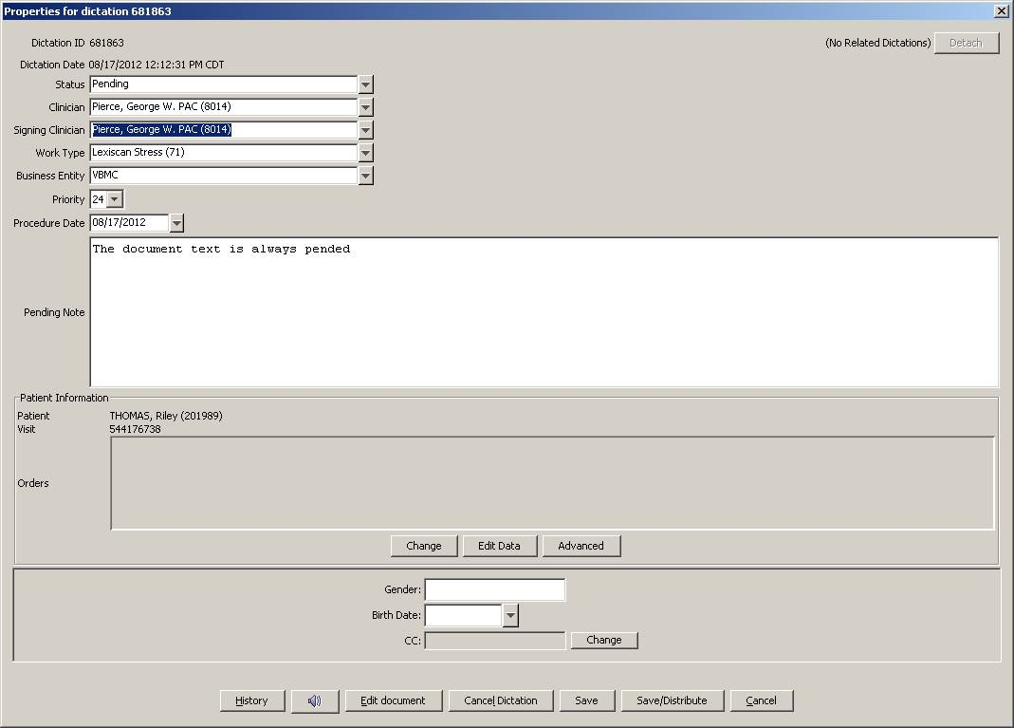

Job# 681864
Here, he says dictating for Dr. Mild. Job got autopended.
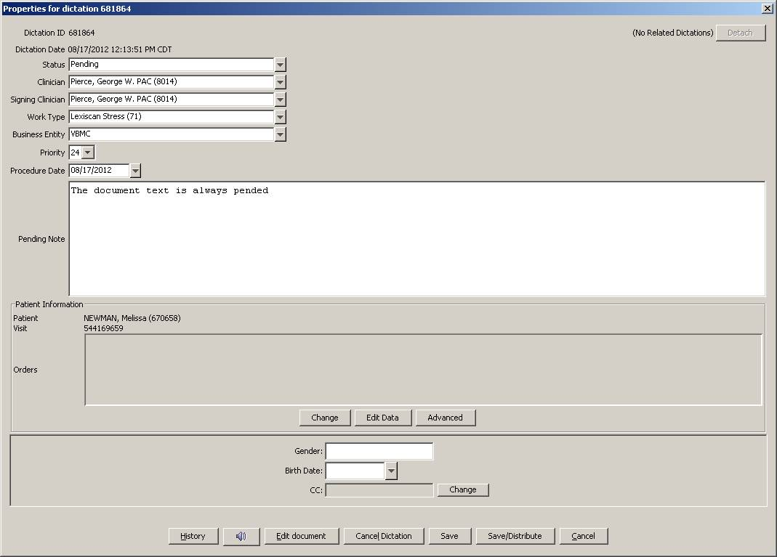

Job# 681865
Here again, he says dictating for Dr. Mild. Job got autopended
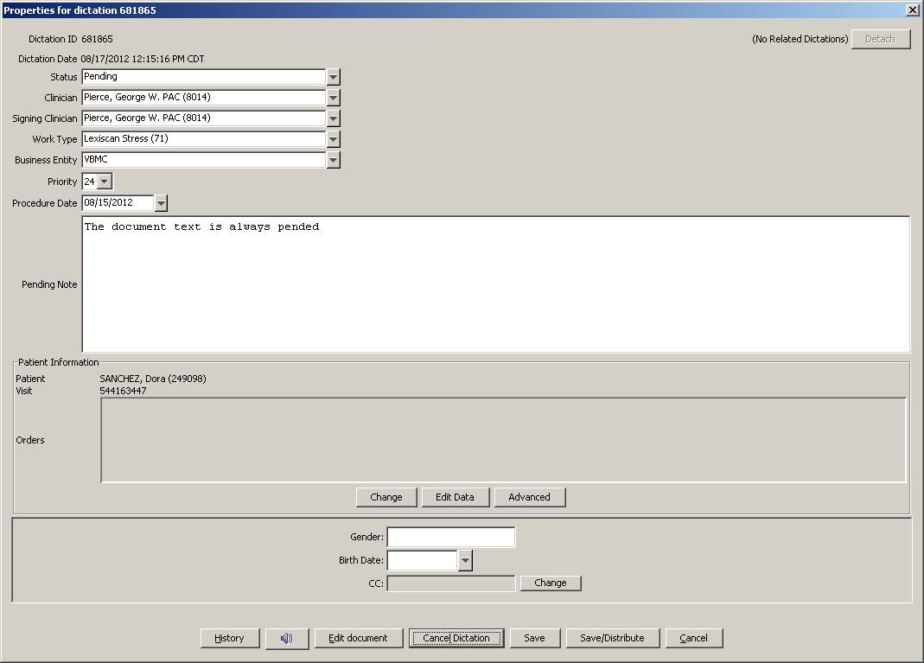

Should be Dr. Adames and not Dr. Thomas
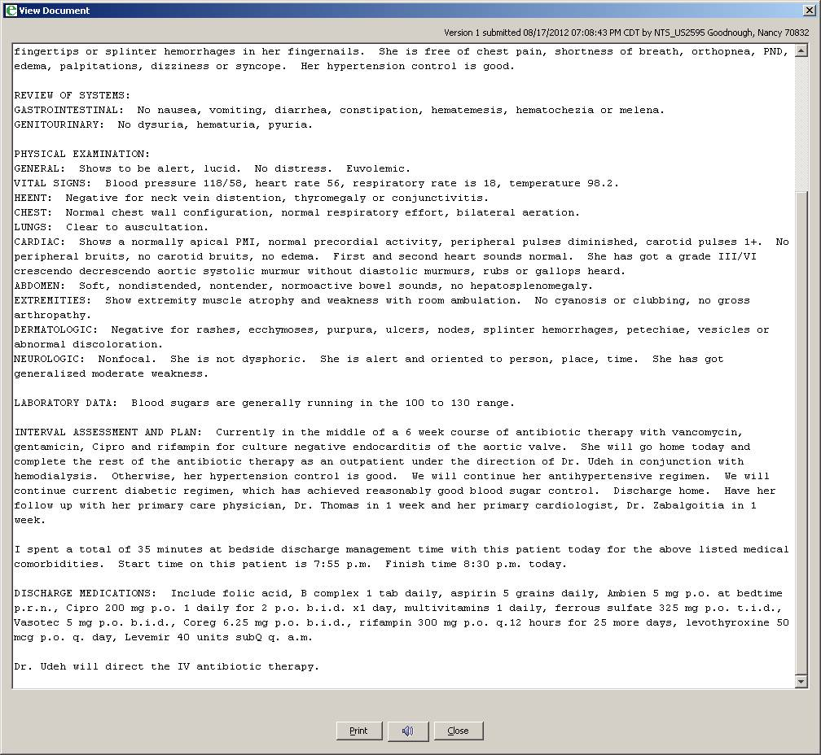

Job#681782
Never use patient name in the body of the report. This is very clearly mentioned in the account specifics. Please remove the patient’s name and use “The patient”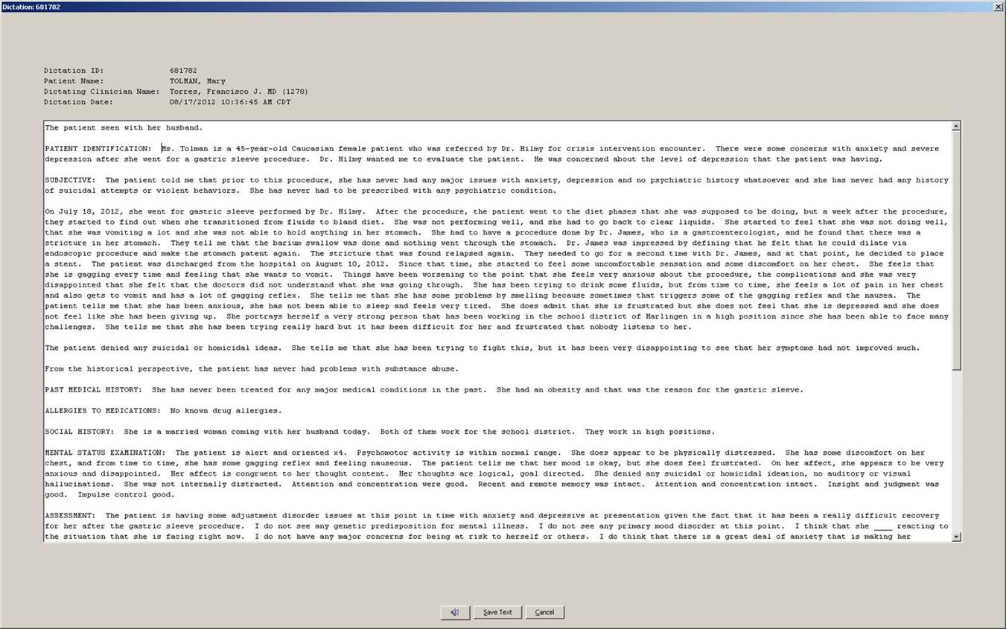

Job#682215
Dictates “my attending Dr. Broughton”
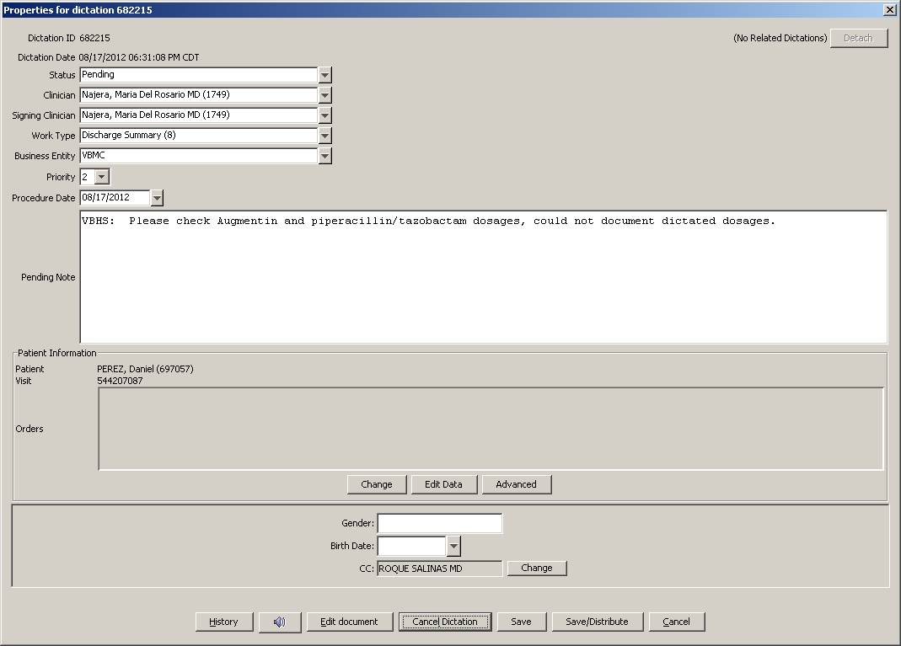

Job#682901
She says “Dictating for Dr. Vasquez (Pedro)”
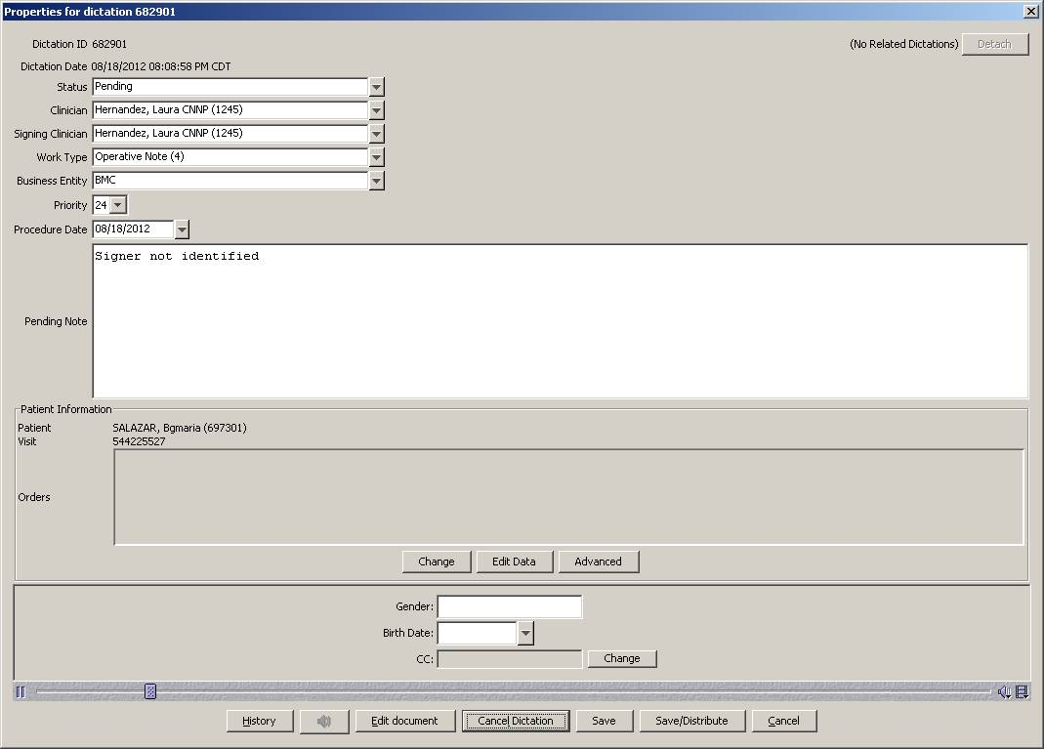

3. Dr. Shenkenberg needs all his reports as a priority within TAT. He gets upset if his jobs are delayed or out of TAT.

4. An update. When Dr. Lopez dictates his progress notes, he dictates: “CARDIOVASCULAR, bold and underline”. He dictates this on all of the physical exam headers. We know it is not possible to bold and underline in this system. Just leave the header as is. Client wants us to know what exactly is being dictated, because we had few reports where MTs transcribed it as CARDIOVASCULAR: Underlying. Sinus rhythm.

5. Date of Birth not prefilled in the header: We have seen multiple reports with DOB field not prefilled. Please go ahead and fill it as per the ADT.

6. Split Dictations: We have requested the authors to clearly dictate the MR# and the patient name while dictating multiple patients. If you still face the problem with ADT selection, please select unknown patient and pend it for client review.

7. Signed Samples: We had requested the client to send us signed samples of Dr. Gerardo Sanchez and Dr. Ricardo Ochoa. Client wants us to use the samples available in the database. Both of these authors have signed their rat eports and have not made any changes/corrections.

8. Hernandez, Laura CNNP (1245): Laura Hernandez dictates for “Dr. Sanchez,” but only Gerardo Sanchez is the Neonatologist for BMC and should be selected as the signing clinician. Do not select Dr. Erwin Sanchez. He is from VBMC business entity. We are putting an MT instruction in place.

9. Date of Assessment, Date of Admission and Date of Discharge: Few authors dictates these dates. Please DO NOT add them in the body of the report. Strictly follow MT instructions for Date of Service.

10. Worktype Change: Flores, Jorge H. MD (6237) keys in wrong worktype. He keys in Progress Note but dictates H&P. Please be extra careful with his reports and change the worktype as dictated. Example job#.684972, 684970, 685701.

11. Job# 685628 – MT left in “I want you to erase Subjective” – those were just instructions to the MT, and MT transcribed it.

12. Job# 685488 – This report had a contract in it – first sentence contained “that’s” DO NOT use contractions.

13. Sanchez, Gerardo D. MD (24329): Please check MT instructions.
  - Under Progress Notes, authors requests to insert normal Physical Exam template for Male/Female twice. Please insert it only once.
  - Vital Signs if not dictated, please delete it.
  - At the end of the report he dictates, “dictation to be checked for accuracy.” Please retain the text at the bottom of the report as dictated.

14. Co-signer for PACs/RNs: PACs and RNs require signing clinician. They always will dictate the co-signer’s name. Please put the name in the signing clinician field. Please check MT instruction.
15. – Please do NOT touch any pending report that shows //TBA at the front of the pending note. These have already been touched by the client and they are awaiting demographics.

16. Todd D. Shenkenberg, MD (320) - I am seeing lot of his dictations being pended with the pend note “Please Verify ADT.”

Please note that he dictates 11 digit numbers in the ADT details, i.e., 0 – 0 - then 6 digit numbers and then 3 digit numbers (e.g. 00523661-442). While selecting the ADT, please ignore first two zeros and the last 3 digits (this is the room number). Put only the 6 digits in the MRN field and search, you will get the ADT. If you still do not get it, please pend the job.

17. Please note that Sarhill, Nabeel MD (864) wants ROS and PE templates to be inserted in all of his H&Ps, PNs, and Consults. Note that he always dictates only the abnormal findings. He wants us to insert these templates and make necessary corrections as dictated.

I reviewed few of his reports and found that he sometimes requests to insert the PE template but never requests for ROS one. We are putting an MT instruction in place and I will let you know once it is updated.

For now, please follow this for all his H&Ps, PNs, and consults. Insert ROS and PE template by default.

